| **Test Name** | | Modify/Update an Error | | | |
| --- | --- | --- | --- | --- | --- |
| **Use Case Tested:** | | Use Case 2 - Modify/Update an Error | | | |
| **Test Description:** | | User update an existing error  User searches errors to find error that requires correction.  User selects error record.  User is presented with the current data for the existing error in the Error Form.  User makes necessary changes to field/s  User submits form | | | |
| **Pre-conditions** | | Error must exist in the system | | | |
| **Post-conditions** | | The database is successfully updated with the new data for the error. | | | |
| **Notes:** | |  | | | |
| **Result (Pass/Fail/Warning/Incomplete)** | |  | | | |
|  | **TEST STEP** | | **EXPECTED TEST RESULTS** | P | F |
|  | User selects “Search Error” from the menu bar | | A list of errors in the database appears | X |  |
|  | User refines search by entering patient name/id in the search field | | List of errors for patient is returned | X |  |
|  | User selects error to be updated | | Data for error is loaded into the Error Form | X |  |
|  | User updates field/s that require correction | | No error appears | X |  |
|  | User selects Submit button | | Message appears that form has been successfully been updated | X |  |
|  |  | | Database updated to show new details for error | X |  |

|  |  |  |  |  |  |
| --- | --- | --- | --- | --- | --- |
| **Test Data Table** | | | | | |
|  | **1** | **2** | **3** | **4** | **5** |
| Test 1 – Patient Search | Kenobi |  |  |  |  |
| Test 1 – Error ID | 11 |  |  |  |  |
|  |  |  |  |  |  |
|  |  |  |  |  |  |
|  |  |  |  |  |  |
|  |  |  |  |  |  |

Search Errors selected from Menu bar:  
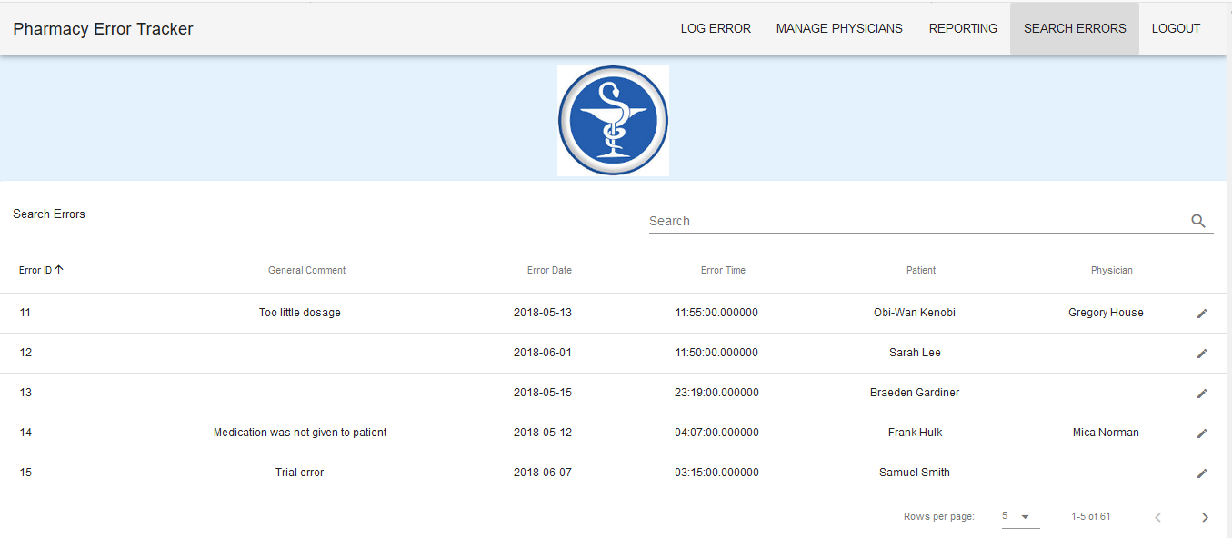

*Note: local database has Error ID values start at 11.*

Search is refined to search for Kenobi

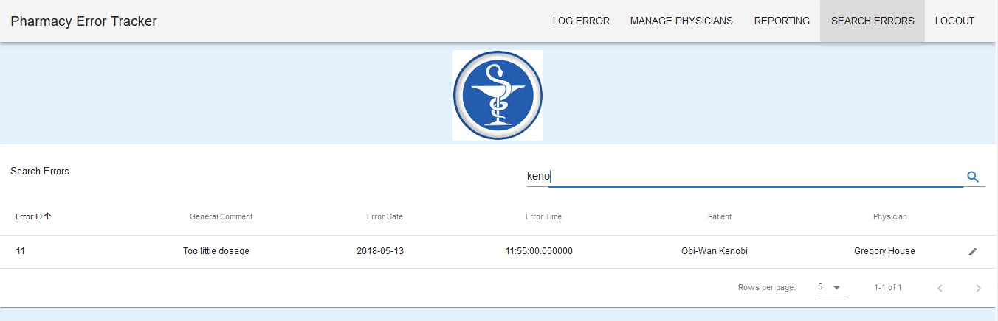

Error ID 11 selected to be edited. Current information from the server:

When Error ID 11 is selected from the search, the information is loaded into the Error Form:  
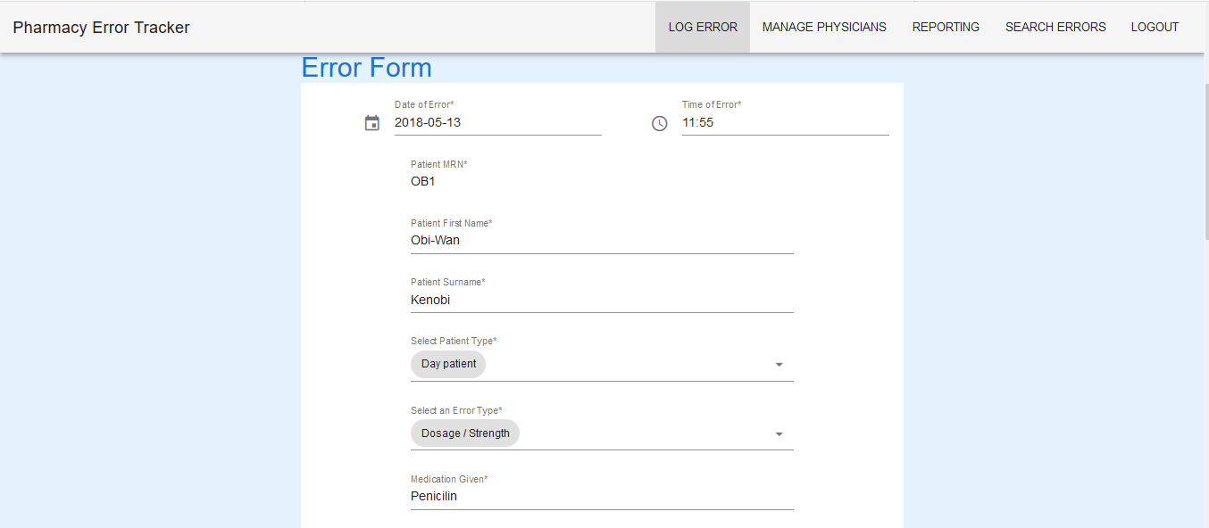

Details to be changed:

Date: 2018-05-13 > 2018-07-06

Time: 11:55 > 06:50

Patient First Name: Obi-Wan > Obi Wan

Patient Type: Day Patient > Inpatient

Error Type: Dosage/Strength > Form Intravenous

Medication: Penicillin > Panadol

Medication Type: Oral > Intravenous

Comment: Too little dosage > Incorrect medication

Person who made error: Shu, Wang > Noble, Jessica

Person Notified Yes > No

Error detected: On the ward > Dispensary

IIMS completed : Yes > No

Severity Level: Minor > Moderate

Physician Notified: Yes > Yes

Provider Number: DR123 > Jdin0958

Physician First Name: Gregory > Mica

Physician Surname: House > Norman

Physician Comment > Testing

After Submit Button is selected, message returned:  
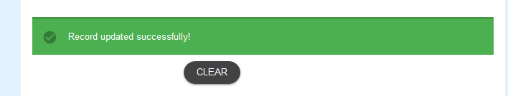

Details from Server:

Before After  
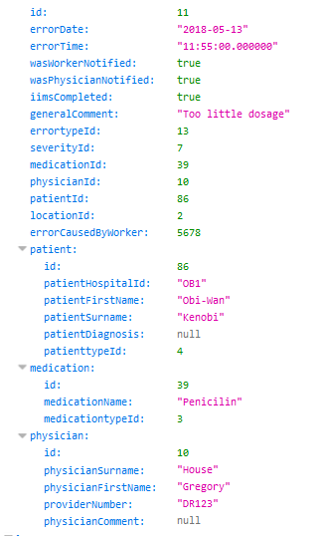 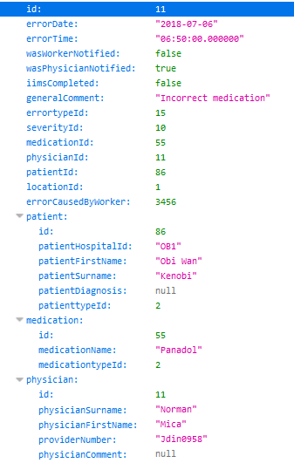

Passed as all changes were made.

Server Command Prompt Window after Submit has been executed.

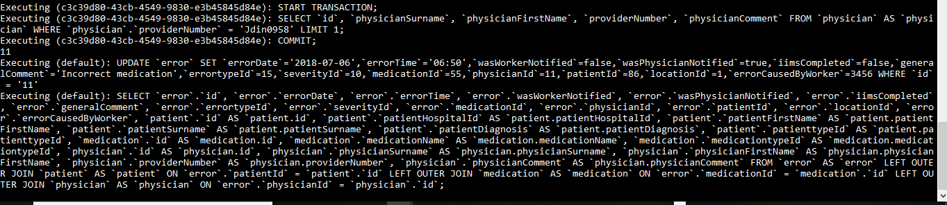

A search for Kenobi shows only 1 record which has been updated:

